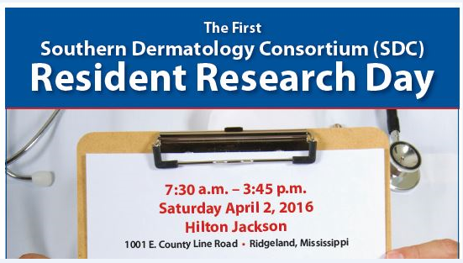

7:30-8:00 am **Registration & Continental Breakfast**

8:00-8:20 am Michael Cosulich, MD, University of Mississippi Medical Center,

Jackson

8:20-8:40 am Julie Rembold, MD, University of Arkansas, Little Rock

8:40-9:00 am Lauren Craig, MD, University of Mississippi Medical Center, Jackson

9:00-9:20 am Tiffany Mayo, MD, University of Alabama @ Birmingham

9:20-9:40 am Allison Cruse, MD, University of Mississippi Medical Center, Jackson

9:40-10:00 am Mallory Shiver, MD, University of Arkansas, Little Rock

10:00-10:20 am **Break**

10:20 -10:40 pm Maureen Offiah, MD, University of Mississippi Medical Center, Jackson

10:40-11:00 am Slade Stratton, MD, University of Alabama @ Birmingham

11:00-11:20 am Andrew Johnson, MD, University of Arkansas, Little Rock

11:20-11:40 am Allison Jones, MD, University of Tennessee, Memphis

11:40-12:00 pm Virginia (GiGi) Alldredge, MD, Tulane Medical School, New Orleans

12:00-1:00 pm **Lunch**

1:00 -1:20 pm Meredith Wagner, MD, University of Tennessee, Memphis

1:20-1:40 pm Megan Couvillion, MD, Tulane Medical School, New Orleans

1:40 -2:00 pm Joy King, MD, Department of Pathology, University of Mississippi Medical Center, Jackson

2:00-2:50 pm Bringing Clinical Research to Life through Instructive Cases from the Deep South, Robert T. Brodell, MD

2:50-3:45 pm Interchange and planning for possible 2017 Southern Dermatology Association (SDA) Resident Research Day or SDA Annual Meeting of a different sort.